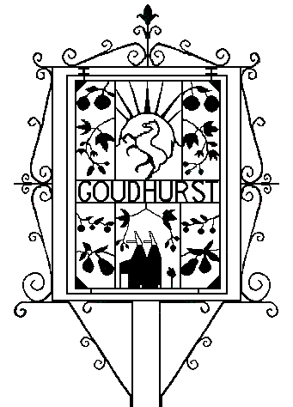
Goudhurst Parish Council

There will be an Extraordinary Meeting of Goudhurst Parish Council on Tuesday 06

February 2024 at 7.00 pm in the Church Rooms, Back Lane.

AGENDA

- Apologies for absence

- Declarations of Interest

- To receive questions and statements from members of the press and public.

This is an opportunity for members of the public to ask questions or raise
issues of local interest. Thereafter they are welcome to stay and observe the
rest of the Meeting (members of the public are not permitted to speak during
the remainder of the meeting except by special invitation of the Chairman)
Public Bodies (Admission to Meetings) Act 1960, s1. Please note, Council
cannot lawfully decide on items of business not specified on the published
agenda although the Chairman may decide to refer any issues raised for
further discussion (LGA 1972 Sch 12 10 (2)(b)).

- To resolve to close the meeting to members of the public and press.

In accordance with Public Bodies (Admission to Meetings) Act 1960, s2
members of the public and press will be excluded for consideration of items 5
to 7 owing to the commercial sensitivity of the business to be transacted.

- To resolve to approve the proposed questionnaire for immediate distribution.

- Council to resolve and confirm that council has made no decision to buy an additional community asset and no offer from GPC has been made.

- Council to confirm that no member has been appointed to negotiate any potential purchase on behalf of GPC

- Council to resolve that it has no intention of purchasing an additional community asset but will assist where possible in finding a positive outcome to support its medium to long term future.

- Council resolves to await the result of the questionnaire and proposed future public meeting before deciding how best to support the various projects.

Next Parish Council meeting Tuesday 13 February 2024, 7.00pm in the Church Rooms, Back Lane..

Proposed by

Cllr Phil Kirkby
Vice Chair of Goudhurst Parish Council
31st January 2024

Cllr Caroline Richards
Vice Chair of Goudhurst Parish Council
31st January 2024

Parish Council Office - The Hop Bine, Ranters Lane, Goudhurst, TN17 1HN
01580 212552 | clerk@goudhurst-pc.gov.uk | https://goudhurst-pc.gov.uk | 07494 117313

Quorum for Council: 4 Members

