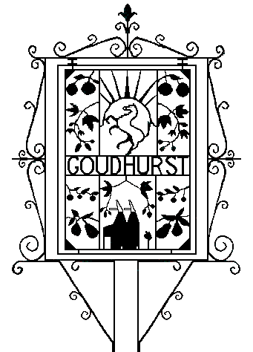
Goudhurst Parish Council

PLANNING COMMITTEE
Minutes of a Meeting held on Tuesday 26 September 2023 at 6.30pm in Goudhurst Village Hall

PARTICIPANTS
Councillors Present: Cllrs Craig Broom (Chairman), Edward Hodgskin, Ed Reed-Cutting, Suzie Kember, Caroline Richards and Paul Wareham.
Officers Present: Claire Reed, Clerk.

APOLOGIES FOR ABSCENCE
347/23 Antony Harris (KALC).

DISCLOSURES OF INTEREST
348/23 There were none.

PLANNING APPLICATIONS FOR CONSIDERATION:

349/23 23/02441 - Risebridge Cottage, Blue Coats Lane

Two storey extension and addition of conservatory
Location within: |  | Type of Development
AONB |  | New build
Conservation Area |  | Conversion
Limits to Build |  | Listed Building
 |  | Business or Commercial
Consider for escalation? | N | Residential | X
 |  | Extension | X

Recommendation: Approve

350/23 23/02412 - 7 The Old School, Goudhurst

Proposed alterations to conservatory to form garden room
Location within: |  | Type of Development
AONB | X | New build | X
Conservation Area |  | Conversion
Limits to Build | X | Listed Building
 |  | Business or Commercial
Consider for escalation? | N | Residential | X
 |  | Extension
Recommendation: Approve

DATE OF NEXT MEETING
351/23 Planning Committee, Tuesday 10 October 2023 at 6.30pm in the Church Rooms, Back Lane.

The meeting closed at 6.32pm

Claire Reed, Clerk

