Kilndown Village Newsletter
August 2023

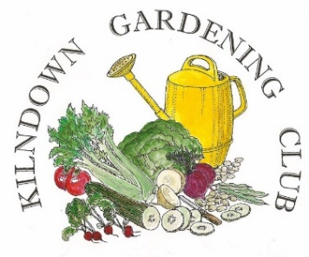What a difference to last year! The Summer Evening Show on 6 July this year had around 40 entries as opposed to less than 25 in 2022. We had added extra classes, which were well supported. The Quarry Centre was full of scent from roses and sweet peas. There were several exclamations about the perfect peas in pod, entered by Christine Macey. Last minute entries were put in by Sarah Heaton and with these she swept the board, winning both the Legat Challenge Cup for Best Rose Exhibit and the Sweet Pea Vase for Best Exhibit those classes.
The next evening meeting is on Thursday 3 August, when we will be taken around Four Gardens in Rome, with commentary by Caroline Halfpenny. Meeting begins at 7.30pm at the Quarry Centre. In September we are hopping of to the Galapagos Islands! The Autumn Flower Show is on 23 September in the Village Hall.
With the demise of David Denton, we (like many others in the Parish) are having to source items from elsewhere, and no doubt will have to pay far more than David charged! As we had run out of Prize Cards for the Summer Evening Show, some were bought (in a hurry) from a gardening charity, but at a price – luckily one of our members has covered the cost. This situation does mean, in the long run our bank balance will diminish, and we’ll have to look at what we as a Club are going to do. So, with that thought in mind, now is the time to start taking cuttings of many species of plant in readiness for the 2024 Plant Sale!

The Quilting Group meet at the Quarry Centre on Tuesdays between 10am and 12 noon. Do you need help with knitting, crochet, sewing? Pop in and ask, there’s bound to be someone who can help! Do you have a special occasion coming up next year – a new baby, a wedding, an anniversary, a BIG birthday? Looking for something unusual or maybe even unique? The QG take commissions, come along, and take a look at the album of completed quilts, inspiration may strike! A Sale is being planned, with a possible date of October 29. Quilts, fabrics and more.

Bag a Bargain! Goudhurst Village Hall has two Jumble Sales planned, Saturday 12 August and Saturday 4 November. Doors open 10am -12 noon.
1
During June and July, we hosted a Pop-Up Tea Room, organised by Grainne, which brought in a few new faces from the village and some passers-by in the form of walkers and on one day a group of Dutch cyclists. The Centre was used for the Kilndown Gardening Club Summer Evening Show, the Community Choir rehearsed a few times there. The Quilting Group meet regularly on Tuesdays. Tables and various catering items were lent for David D’s Memorial Service at Christ Church. There’s a lot going on at the QC, quite often behind the scenes. It’s not just the Saturday Shop, it’s a place for everyday (or evening)!
Three swift boxes have been installed on the ‘phone box’ end of the building. Thank you to Butch for helping with this. The QC Team are now keyholders for the Village Noticeboard by the Quarry Pond. (Posters for the board may be emailed to Lynda or brought in on a Saturday). By the time this is being read, we hope to have completed a tidy up of the board, as in fixing the locking system, re- puttying the glazing and treating the woodwork with preservative. This will have been carried out on a volunteer basis, with any costs incurred covered by the QC. After torrential rain in one day June the two Johns, spent around two hours shovelling and raking the QC frontage as the water rushing down the road had rearranged the stones!
WE HAD A TW LOTTO WINNER! One of our supporters won £2,000 a few weeks ago. For your chance to win a similar amount or even more, just look up TW Lotto. The QC gets half of your spend and the rest goes to various local charities.
Recently we sent two boxes of used printer cartridges for recycling and in return received £15.90 for those that could be reused and put back into the system. Thank you to all who bring in their cartridges. ‘Every little helps’, as the saying goes! There is still a collection box for used postage stamps in the Centre, when full this will be passed to the RNIB. Most weeks we are able to send two boxes of donated groceries to the GK Community Cupboard. Generally, the goods have come off our shelves, with customers adding an extra £5 or £10 to their QC shopping, but goods from anywhere else are welcomed.

KILNDOWN EDUCATION TRUST

Kilndown Education Trust is a charity formed in 1994 after the closure of Kilndown Primary School. The Trust has funds available for young people up to the age of 25 living in the parish of Kilndown who might benefit from financial support for any aspect of their education. Grants are not means-tested. We continue to support our two local primary schools where Kilndown children are taught. Grants towards various educational extra-curricular activities, including university textbooks, music and swimming lessons, were also made to 44 individual students last year (2022). If you are not sure if you qualify, please feel free to contact the Secretary.

The next round of grants will be awarded in September 2023; the closing date for applications is September 1st, 2023.

Hilary Bird (Secretary)
Rogers Rough
Chicks Lane
Kilndown
Kent TN17 2RP Telephone: 01892 890554 e-mail: hilarybird7@gmail.com

2

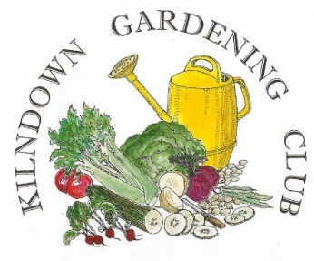
A Gardener Abroad ~ Four Gardens in Rome Presented by Caroline Halfpenny

Quarry Centre ~Kilndown
Thursday 3rd August ~ 7.30pm ~ Members Free ~ Visitors £3

VILLAGE HALL & MILLENNIUM GREEN
The Hub returns on Tuesday 12 September. Tea, coffee and chat, with a new time of 2pm to 4pm. The Film Club is set to return on the last Friday of the month, starting 29 September. Look out for advertising nearer the time.
New aluminium football goals were installed on the Green in July to replace the plastic ones that had worn out. Grant funding was acquired through the Football Foundation. The floor in the hall is being refurbished during August.
Snippets of News
A while ago Kilndown and Lamberhurst Cricket Club were asking for memorabilia from more recent years. Just before he died, David Denton was given a box of videos filmed by the late George Hammond and amongst these was a film recording from 1993, when the new pavilion on the Kilndown ground was opened by Sir Colin Cowdrey. This has been passed to K&LCC.
**
POP up PUB, The Scotney Team have offered a private tour on 17 August at 6.30pm. The suggestion would be a walk down to the Old Castle to both enjoy the garden and view an Exhibition they have there, ‘The Red List’ which highlights the plight of endangered birds. They would link in to how we are managing the estate for the benefit of nature, something they hope would be of interest to the community that is so interconnected with the Scotney Estate. In addition, it would give anyone interested in the proposals for a new Visitor Centre and alterations to the parking at the Mansion an opportunity to ask questions regarding those plans. Anyone interested in joining the visit and PUP and would like information about other forthcoming events, should email: kilndownpup@gmail.com
**
Goudhurst and District U3A’s 16 August meeting is at 2.30pm in Goudhurst Village Hall. The guest speaker is Michel Smith talking about the race to the South Pole which ended in the tragic death of Captain Scott and his team. Guests and potential new members are very welcome.

**

Community Lunch. Held every Tuesday at St. Mary’s, Goudhurst. Drop in between 11.30am – 1pm for a delicious bowl of homemade soup with bread and cheese, followed by a hot drink and something sweet. Children on school holidays are welcome too. Community Lunch is open to everyone in the Parish. There is no cost.
3
Friends of Kent Churches
Ride & Stride
The Friends of Kent Churches Sponsored Ride & Stride takes place on the second Saturday in September each year. This year it will take place on Saturday 9th September. To register as a participant, for further information, or to request a sponsorship form, contact Tina Gallagher at tinagallagher22@aol.com or phone 07909 946195 or visit www.kentrideandstride.co.uk.

Participants plan their own routes with the assistance of a printed list of churches and chapels open. There are usually some 700 of these places of worship open, scattered right across this big county, and wherever you go you’ll be assured of a warm welcome. Go individually, as a couple, with friends and family, with a cycling club, with your work colleagues, with school friends, with choirs, with a sports team – whoever you wish. You need a special sponsor form. Please ask sponsors to tick for Gift Aid if they are taxpayers; this increases their donations by 25% with no cost to them. Ask your relations, friends and colleagues to sponsor you – so much per church or chapel visited between 10 am and 6 pm on the day. 50% of all sponsorship money raised can go to the church or chapel of your choice, with the other 50% going to the Friends of Kent Churches, who distribute it by grant aid to help the neediest churches in the county. Christ Church Kilndown hopes to benefit from such a grant when the ‘Toilet Extension’ revised plans are approved.

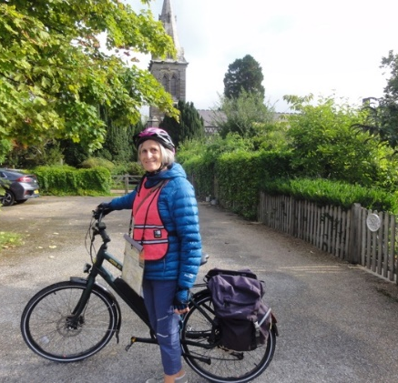

Tina Gallagher will be cycling around the churches again this year. Something she has done most years since the ‘Ride and Stride’ started. She would love to get as much sponsorship as possible as half of what she raises will come back to Christ Church to the ‘loo’ fund. If you would like to sponsor her, the contact details are above – or there will be a sponsor form in Christ Church on Sundays! She is hoping the battery on her electric bike won’t run out this year!

FUND RAISING

This is something we in Kilndown have always been good at, looking back at archives over the years, there have been countless Sales of Work, Christmas Bazaars, Pram Races, Quizzes, Dances of all kinds, and not forgetting the Fetes of the 1970’/80’s, you name it we seem to have done it! All in the name of raising money for something or other in the village or beyond. Some may recall the Quarry Centre fundraisers for the toilet – Barbecue for a Loo, Bog Boogie, Warts & Witches etc. Quite often the QC teamed up with the Village Hall and /or Christ Church, as being a small village having too many events in a short space of time could have been overwhelming. The QC Team are working on a few ideas – as they say watch this space!

4

AUTUMN FLOWER SHOW
Saturday September 23
Kilndown Village Hall 2.30pm
Classes for Fruit, Vegetable, Floral Art, Cookery, Pot Plants
Bring & Buy Table ~ Refreshments
Prizes presented 4pm
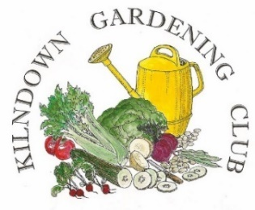
Details – lyndashepherd549@gmail.com
Diary Dates
Every Tuesday – Quilting Group – Quarry Centre 10am – 12 noon
Every Tuesday – Community Lunch – St Mary’s, Goudhurst 11.30am – 1pm
Every Tuesday – From September 12 – Community Hub – Village Hall 2pm – 4pm
Every Saturday – Quarry Centre Saturday Shop open 9am – 12 noon
August 3 – A Gardener Abroad – Quarry Centre 7.30pm
September 7 – Galapagos Islands – Quarry Centre 7.30pm
September 23 – Autumn Flower Show – Village Hall 2.30pm
September 29 – Film Club – Village Hall * Details TBA
September 30 – Macmillan Cake Sale – Quarry Centre – 9am – 12 noon * Donations appreciated.
October 29 – Quilts & Fabric Sale – Quarry Centre - * Details TBA

CHRIST CHURCH FLOWERS

As at time of writing there are several spare dates on the Flower Rota. If you would like to’ have a go’, please get in touch with either Angie or Lynda. The next Festival will be Harvest, date TBA, when it’s all hands on deck!

5

Looking Back
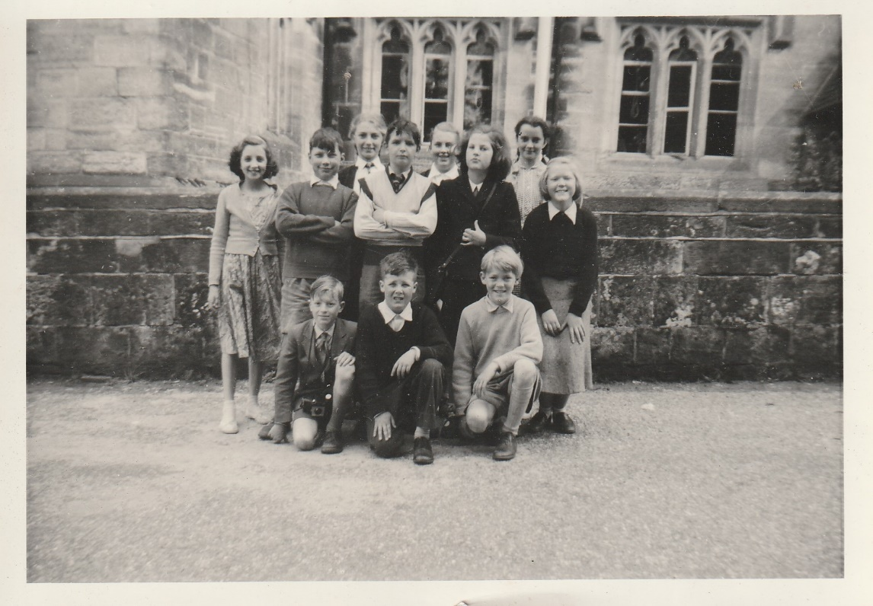
This photograph turned up recently. Taken outside Kilndown School around 1958/59. Names suggested so far are: Top Row: Josephine Martin, Celia Balderstone, Sue Dengate, and ?
Middle Row: ? ? Mary Johnson, Lorna Batchelor, Bottom Row: Nigel Blunt, Peter Johnson, Robin Batchelor

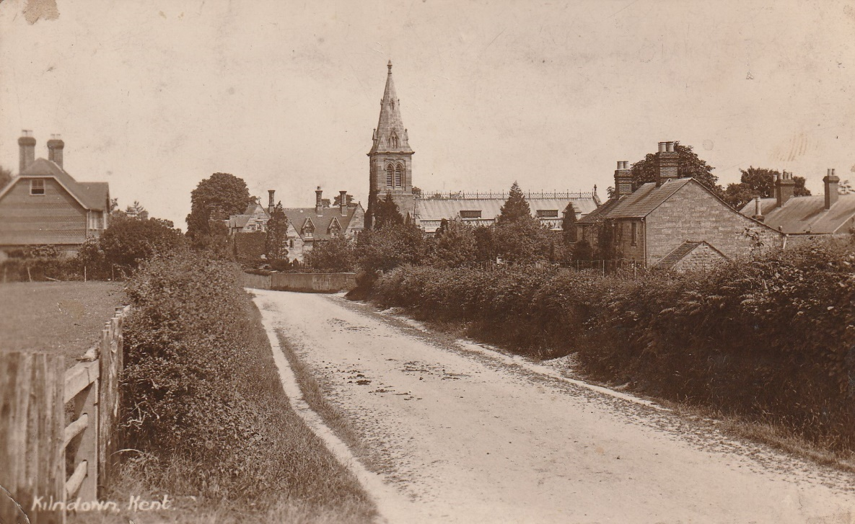
Before Highdown Cottages were built.
6

