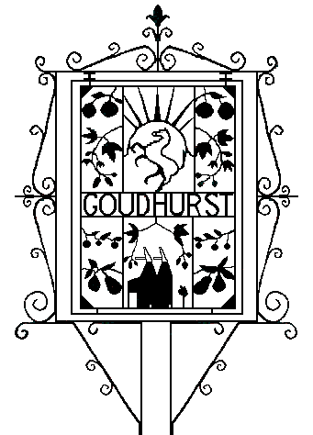
Goudhurst Parish Council

Memorial Application Form

Before completing this form please read the Burial Regulations carefully. A memorial falling outside the terms of the Regulations will not be approved. The regulations can be found on the Parish Council’s website at https://goudhurst-pc.gov.uk/burial-information-and-fees/. Applications to erect or make changes to a memorial should be sent to Mrs Claire Reed, Clerk to Goudhurst Parish Council at Clerk@goudhurst-pc.gov.uk or via post to Goudhurst Parish Council, The Hop Bine, Risebridge Farm, Ranters Lane, Goudhurst, Cranbrook TN17 1HN. No Memorial should be introduced into the Burial Grounds without prior approval from the Burial Authority and until the relevant fee has been paid. The Burial Authority reserves the right to remove any Memorial for which permission has not been granted or an approval fee paid.

Name/ grave reference
Title and Full Name of Applicant
Address

Tel. No.
Name of Monumental Mason
Address

Tel. No.
Type of Grave (please delete) | Full-length Grave/Ashes Plot
Type of Memorial (please delete) | Headstone/cross/wooden cross/ashes tablet
Size of Memorial and Base
Type of Stone, Colour and Shade
Surface Finish
Description of any Carving or Decoration
Wording of Inscription
Type of Lettering
Size of Lettering
Colour of Lettering
Particulars of any Vase
incorporated in the Memorial
- I have attached to this form a sketch or design of the proposed memorial.
2. I have read the current edition of the Regulations relating to Goudhurst Burial Grounds.
3. I apply to Goudhurst Burial Authority to grant permission for the memorial herein described and I undertake that, if permission is granted, the monument will be erected in exactly as described.
4. I attach to this application two photographs, one showing the grave, and the other taken at a sufficient distance from the grave to show the memorials nearby.
5. I further undertake to indemnify Goudhurst Parish Council and Goudhurst Burial Authority against all costs and expenses to which they may be put in respect of any deviation from the undertaking given in 3 above.

Signed: ………………………………………….. Applicant Date: …………………………….
I/We undertake to abide by the above.

Signed: ………………………………………….. Monumental Mason Date: …………………………….

