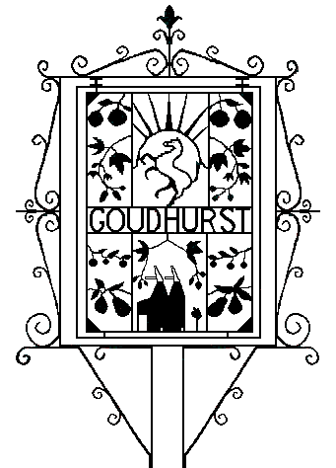
Goudhurst Parish Council

PLANNING COMMITTEE
Minutes of a Meeting held on Tuesday 26 April 2022 at 6.30pm in Goudhurst Village Hall

Present: Cllrs Craig Broom (Chairman), Antony Harris, Barry Noakes, Mrs. Caroline Richards and one member of the public.

- Apologies for Absence: Cllrs Chris Ditton (working), Alan Foster (holiday).
Cllr Mrs. Alison Webster was absent.

2. Declarations of Interest: None

3. Planning Applications for consideration:

3.1. 22/00821 May Farm, Chicks Lane

Conversion and partial demolition of an agricultural buildings to a single dwelling, wider landscaping enhancements.
Location within: |  | Type of Development
AONB | X | New build
Conservation Area |  | Conversion | X
Limits to Build | X | Listed Building
 |  | Business or Commercial
Consider for escalation? | N | Residential | X
 |  | Extension

GPC Recommendation: Approve conditional on a design that doesn’t use fossil fuels for heating as per Goudhurst Neighbourhood Development Plan policy D3.

Comments: Materials should be reviewed and supported by the Conservation and Environment Officers.

3.2. 22/01026 & 22/01027/LBC Marlingate Farmhouse, Bedgebury Road

Erection of single storey extension, internal alterations to the ground, first and second floor, including insulating the roof and the installation of 5 conservation roof lights to the main roof.
Location within: |  | Type of Development
AONB | X | New build
Conservation Area |  | Conversion
Limits to Build |  | Listed Building | X
 |  | Business or Commercial
Consider for escalation? | N | Residential | X
 |  | Extension | X

GPC Recommendation: Approve.

4. Items for Information
An application has been submitted for Crowbourne Orchard for the ‘Change of use of the land for the accommodation of 1 Gypsy / Traveller Family, with static home, day room, stables and touring caravan’. The application is awaiting validation and has been given the reference 22/01066/FULL.

5. Next meeting Tuesday 10 May 2022, 6.30pm in Goudhurst Village Hall.

Claire Reed
Clerk
26.04.22

